Two Furious Oceans
1. A. “You are the Rocky Mountains / white with the snows of centuries. “Eternal rocks that rise…” (Diespecker 14-15).
B. “The flat immenseness of the Prairies / blue with unbound space (Diespecker 24)
“Meadows in the clouds and valleys… (Diespecker 11)
C. Two… “you whose limbs are strong / whose blood is rich with power…” (Diespecker 5-6)
with the secrets… “you are the mountain goat/ poised, majestic and alone…” (Diespecker 19-20)
D. The stately St. Lawrence…/ And friendless wilderness… (Diespecker 28-29)
You are the dainty…/ Of Jolliet the cool sweet whisper of Laurentian breezes. (Diespecker 30-31)
E. “Over the wave-like hills of the Maritimes / maintaining them…/ kindling them…” (Diespecker 36-37)
2. 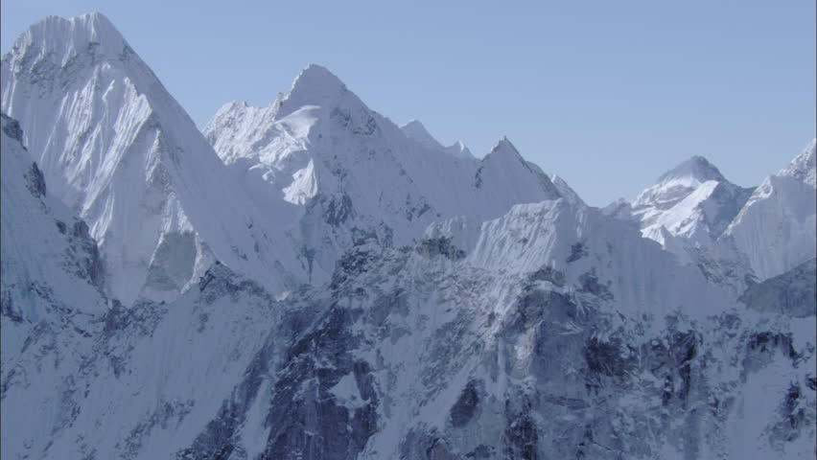
“You are the Rocky Mountains / white with the snows of centuries. “Eternal rocks that rise…” (Diespecker 14-15).
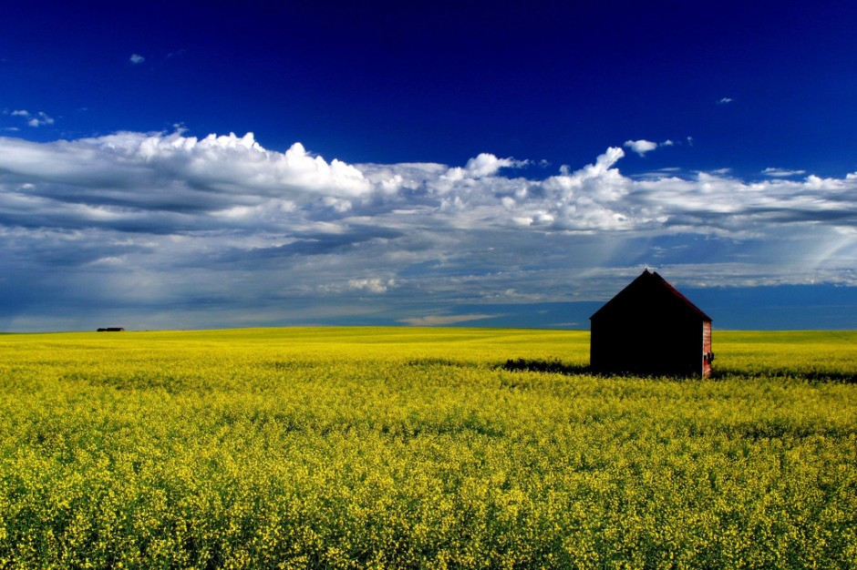
“The flat immenseness of the Prairies / blue with unbound space (Diespecker 24)
“Meadows in the clouds and valleys… (Diespecker 11)
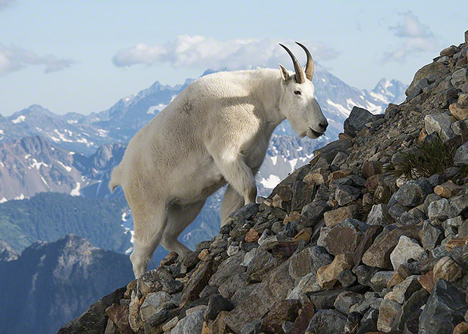
“you are the mountain goat/ poised, majestic and alone…” (Diespecker 19-20)
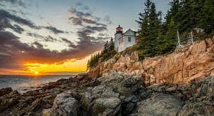
The stately St. Lawrence…/ And friendless wilderness… (Diespecker 28-29)
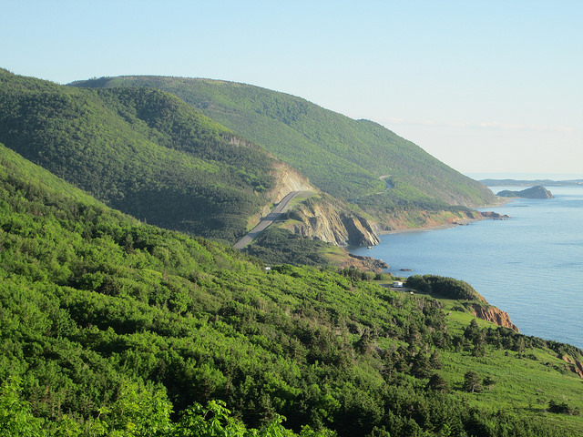
“Over the wave-like hills of the Maritimes / maintaining them…/ kindling them…” (Diespecker 36-37)

3. You are the Rocky Mountains, white with the snows of centuries,
You are the heaving lakes, the rolling, green-jacketed hills
You are the maple groves that undulate, mile upon mile
The purpose of the author in pointing the above contrasts and comparisons is to justify and make the reader understand well that the region being described is very vital. It provides appropriate environment for growth and also protects those who inhabit it. The author intends to explains that the region is more superior than any other and rich with every aspect of life.
4.
a. “…the mournful cry of gulls.” (Diespecker 13)
“Poised, majestic and alone upon the barren crag” (Diespecker 20)
To proclaim the season's death… (Diespecker 39)
Leaving them black and naked…( Diespecker 40)
b. You are the quiet bays and the lonely shadows of the firs… (Diespecker 7)
You are the reckless foothills...( Diespecker 22)
You are the heaving lakes, the rolling, green-jacketed hills…( Diespecker 25)
c. The author has used extensive personification and metaphor to compare and emphasize the supremacy of the region over other areas.

